## Instructions for compiling ISOmodel using Visual Studio 2022 community edition

Download VS 2022 community edition and begin install

Select Desktop development with C++ and use default settings

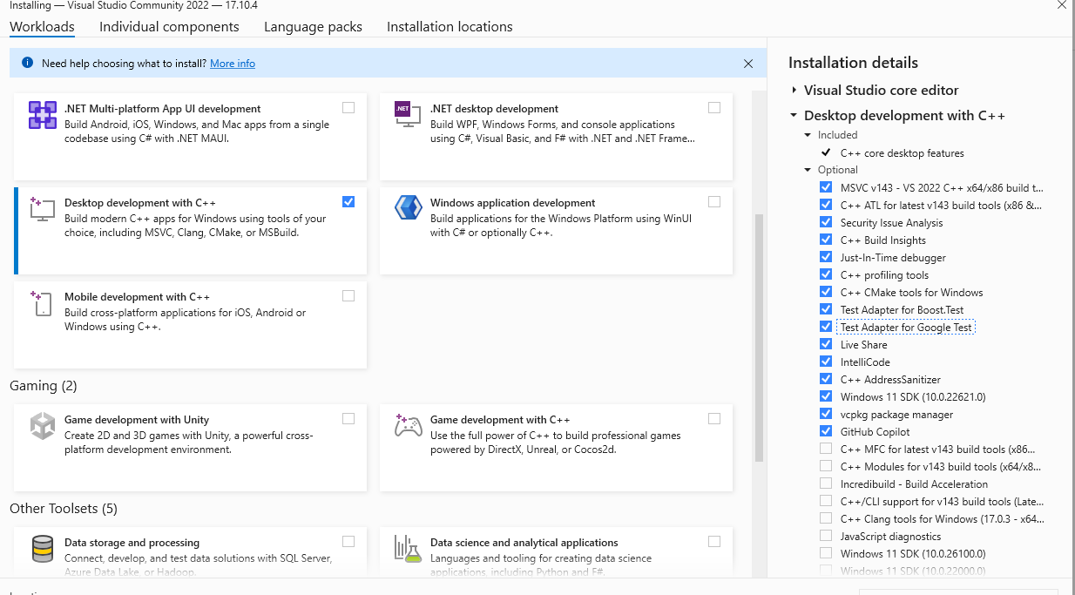

## Install CMake

Installed most current version (3.30.xx on 7/21/24) using chocolatey

choco install cmake

This installs in the path for all users

## Install Boost 1.84.0.1 prebuilt binaries for msvc 14.3

choco install boost-msvc-14.3

Installed to c:\local\boost_1_84_0

Installed to C:\local\boost_1_68_0

## Install Google Test 1.8.1

<https://github.com/google/googletest/archive/refs/tags/v1.15.0.zip>

Installed to C:\local\googletest-1.15.0

## Compiling Google Test using Visual Studio IDE

Now, create the .sln for MSVC in the following way after MSVC is installed

cd googletest # Main directory of the cloned repository.

mkdir build # Create a directory to hold the build output.

cd build

cmake .. # Generate native build scripts for GoogleTest.

This should create googletest-distribution.sln in the build directory

Load the googletest-distribution.sln from the google test build directory, set the build settings and build:

C:\local\googletest-1.15.0\build\ googletest-distribution.sln

Set the build settings to Release and X64



### Build the ALL_BUILD project

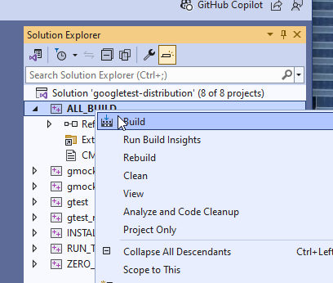

I did a right click on Solution ‘ALL_BUILD’ and selected “Build”

This completed without any warnings or errors on my machine

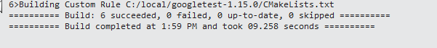

This will generate 4 lib files in the build\lib\Release directory

C:\local\googletest-1.15.0\build\lib\Release>ls

gmock.lib gmock_main.lib gtest.lib gtest_main.lib

You probably want to copy these to googletest main directory to make them easier to link with cmake

i.e. C:\local\googletest-1.15.0\lib

## Compiling isomodel using Visual Studio IDE

First we need to create the .sln files

Go to isomodel directory root (e.g.e c:\git\isomodel\isomodel\) and make a binary directory

cd C:\git\isomodel\isomodel\bin

mkdir bin

cd bin

Then run make with the following command line

cmake ../src -G "Visual Studio 17 2022"

-DBoost_LIBRARY_DIR="C:/local/boost_1_84_0/lib64-msvc-14.3"

-DBoost_INCLUDE_DIR="C:/local/boost_1_84_0"

-DGTEST_INCLUDE_DIR="c:/local/googletest-1.15.0"

-DGTEST_ROOT="c:/local/googletest-1.15.0"

This should complete without errors and hopefully minimal warnings

CMake Warning (dev) at CMakeLists.txt:91 (find_package):

Policy CMP0167 is not set: The FindBoost module is removed. Run "cmake

--help-policy CMP0167" for policy details. Use the cmake_policy command to

set the policy and suppress this warning.

This warning is for project developers. Use -Wno-dev to suppress it.

-- Found Boost: C:/local/boost_1_84_0 (found suitable version "1.84.0", minimum required is "1.55.0") found components: system filesystem program_options

-- Found GTest: C:/local/googletest-1.15.0/lib/gtest.lib

-- Configuring done (5.6s)

-- Generating done (0.1s)

-- Build files have been written to: C:/git/ISOmodel/IsoModel/bin

This worked without errors to create many project files including isomodel_project.sln for visual studio.

Load isomodel_project.sln into Visual Studio

Change build to Release, x64 and build the entire project